Collections Hierarchy:
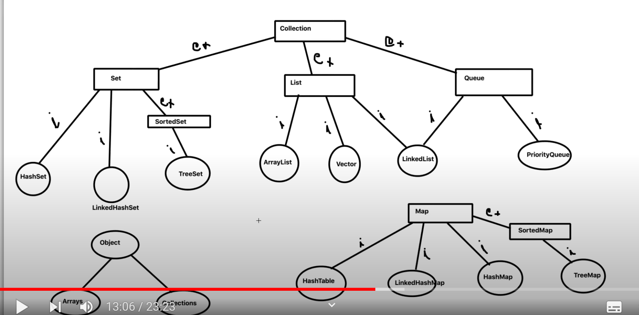

Advantages of Collections:
- Reducing Programming effort
- Provides built-in methods and classes
- Optimized performance
- Increased Productivity
- Reduce operational time
- Interoperability

Differences between all collections
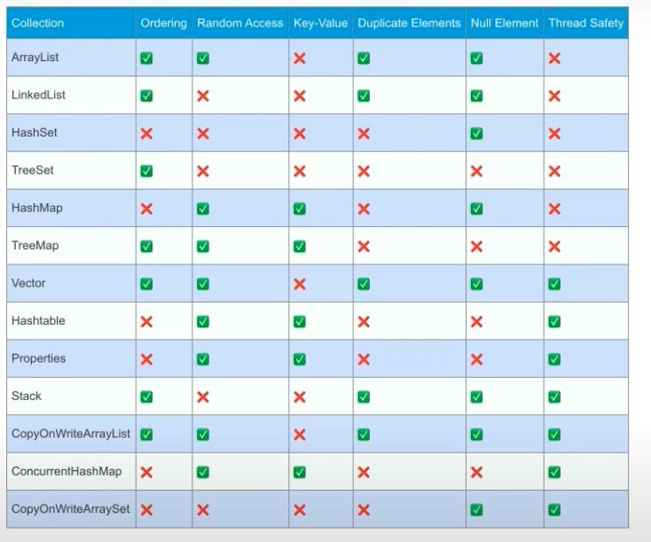
ArrayList:
- It internally uses the dynamic array to store the elements
- Insertion order is maintained
- Random access is possible
- Allows duplicate values
- It is not synchronized
- Allows null values
Random access: You can access the particular element by specifying the index of that element.
Raw type: We can store any type of value whether it is integer, string or anything.
//Default generics of arraylist
ArrayList ar = new ArrayList();
Virtual Capacity in arraylist:
- Virtual or default capacity of arraylist is 10.
- When you are calling the method arr.size() it will give you the physical capacity not the virtual capacity.
- If you want to change the virtual capacity of the arrayList you can change it in the parantheses when you declare the arraylist.
- For example: ArraList ar = new ArrayList(30);(Now the virtual capacity becomes 30).
- We can iterate through the arrayList in 4 ways:
- //typical for loop
for(int i=0;i<arr.size();i++){
list.get(i);}
- //For each loop
For(String s : list){
Sout(s);
}
- //Using streams
List.stream().forEach(ele->System.out.println(ele);

- //Using iterator
Iterator<String> it = list.iterator();
While(it.hasNext()){
Sout(it.next());
}
Methods available in arraylist:
- add(): To add the elements into arrayList
- addAll(): To add the elements of the arraylist into another arrayList.
- clear() : It completely removes all the elements of the arrayList.
- clone() : To create the copy of an arraylist.
- contains() : To check if the particular element is present in arraylist or not. It returns us the Boolean.
- indexOf(): It specifies if that element is present in that index or not.
- remove() : To remove the specific index value just specify the index value or else you can pass the values also.
- removeIf(): You can use this method If you need to do any specific operation like removing the odd or even elements from the given list.
- retainAll(): This method gives you what you are passing.
Example:
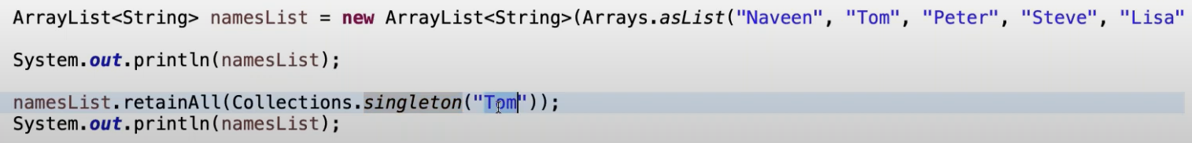
- subList(): From the list you can get the subList.
Example:
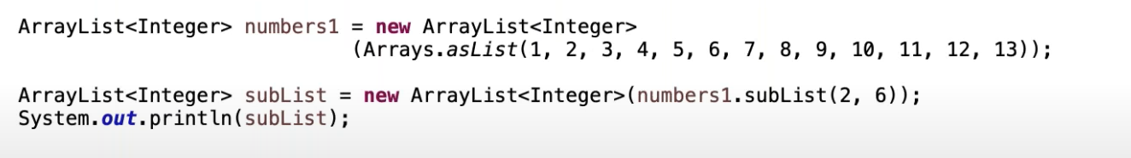
- toArray(): To convert the arraylist into the array.
Example:
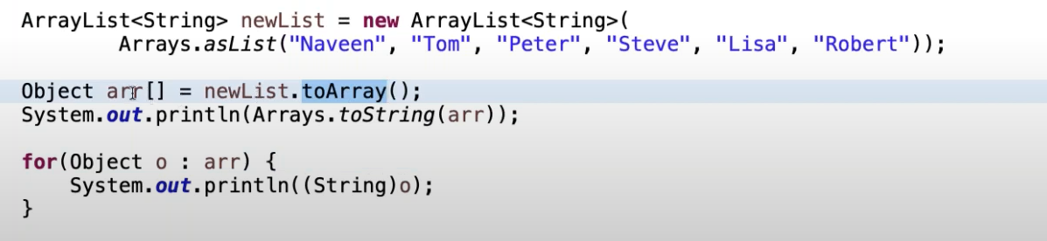

How to Synchronize arrayList:
There are two ways to do it:
- Collections.synchronizedList(): This is the method returns the synchronized list.
- copyOnwriteArrayList: It is a class and It is a thread safe variant of ArrayList.

Thread safe: If one thread is accessing a element and doing some operation on it. Then another thread is also try to access the thread and this thread gets the previous property of the element.
Thread safe means we restrict the threads to access the element when another thread is accessing it. After one thread job is done then only another thread can access or do some operations on that thread.
SynchronizedList: It is returning the List of strings.
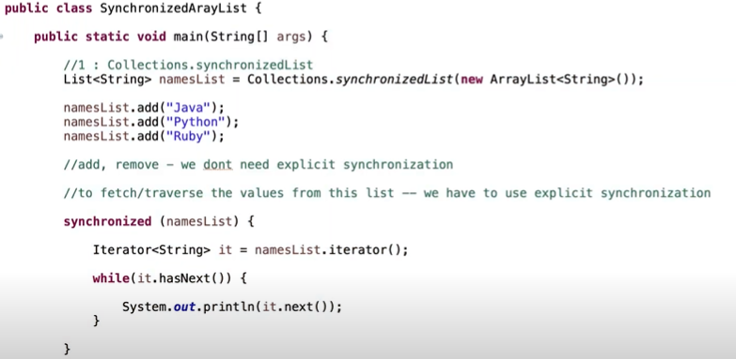
copyOnWriteArrayList: It is a class
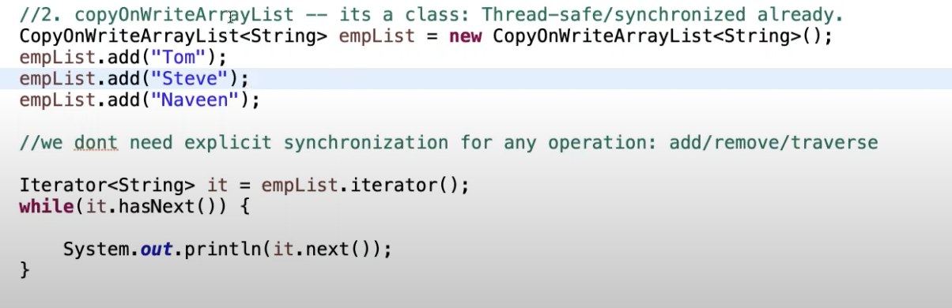

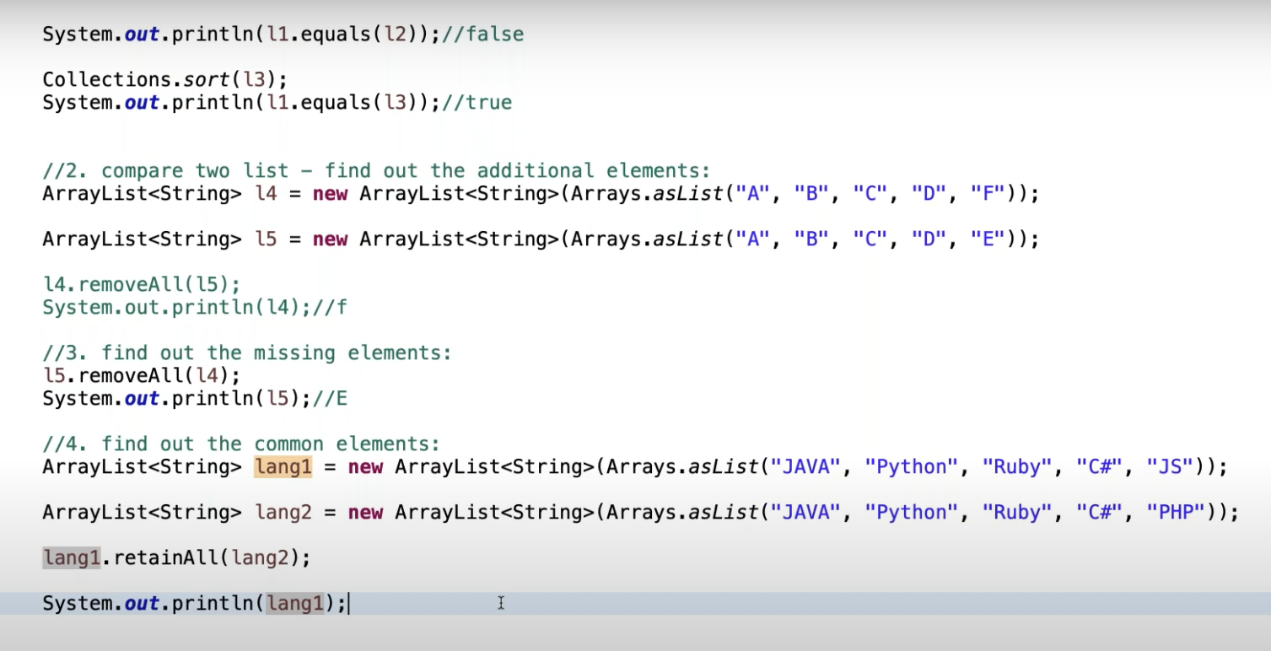

HashMap:
- HashMap stores the values in the form of key-value pairs
- It don’t have any ordering
- Key cannot be duplicate.(If you provide the duplicate key It will return you the latest value).
- Can have multiple null values but can have only one null key.
- It is not synchronized
- HashMap extends AbstractMap and it implements the clonable and Serializable.

Methods in HashMap:
- Put(Key,Value): To add the values into the Map.
- get(): To get the value when you provide the particular key.
- keyset(): To get the set of the keys contains in the particular map. We need to apply iterator on keyset not directly on the Map.
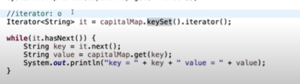

- entrySet(): Stores the set in the form of entry it will not return the iterator of the string.
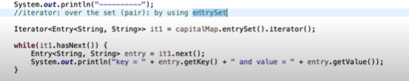

- remove(): To remove the keys from the map by passing the value.

Comparing two hashmaps:
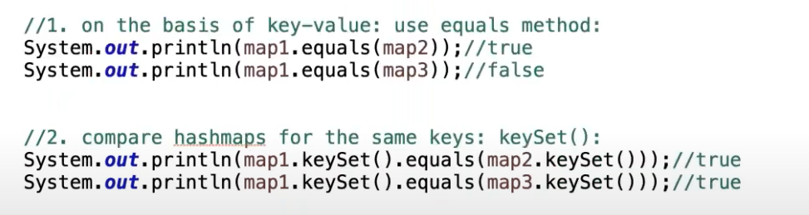
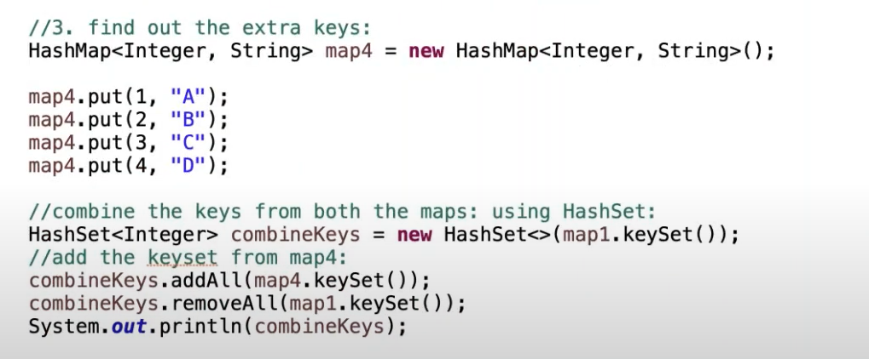

Internal working of HashMap:
1. The moment we create the hashmap it is allocated with the 16 nodes.
2. Every node maintains one key, one value, one hash and one next pointer.
3. Mulitple objects can have the same hashcode.
4. We will store that element as the linkedlist and the node does not points to null but it points to the next element.
5. HashMap collision: Getting the same index for the different hashcode and we are storing the elements in the form of the linkedlist.(put method inserting the values into the hashmap).
6. Get the value(fetch): We will first calculate the hashcode and check based on hashcode if the hashcode gets matched then with the equals method it will check the key if it is same or not if the key is also same then it returns the particular value.
7. so here we can clearly say that hashcode method should override the equals method.
8. If we have the same hashcode for the 2 keys and when we check using the equals method and if the key is not matched it wlll go and search in the next node and if the particular key is found it will return that key.
9. The hashcode of the null is always 0 so the index Is also 0 so the values are stored in the 0 index.
10. equals method is used to compare the keys . used to find the correct key within linkedlist is a linear operation. So TC is o(n)
11. After java 8 To improve the time complexity after certain threshold value(8) is reached linkedlist is automatically converted into balanced binary trees.O(logn)
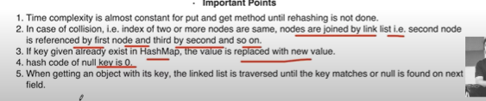
Different ways to create the HashMap:
1. Using the regular HashMap class
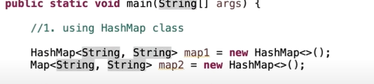
2. Using the static block:
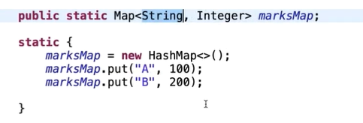
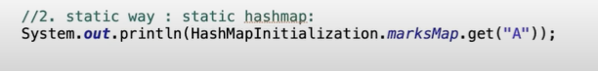
We generally don’t prefer to use the static block because we will get the stack overflow error.
3. Immutable map with the single entry


4. Java 8 using streams:
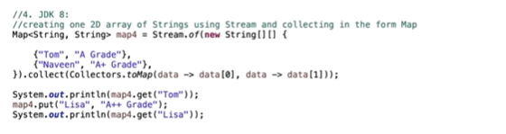
5. Using simpleEntry
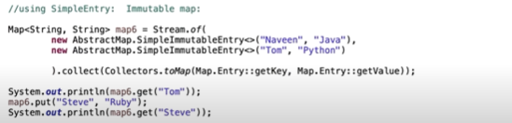
6. JDK 1.9:
//Empty map
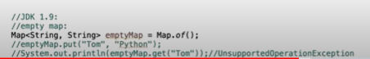

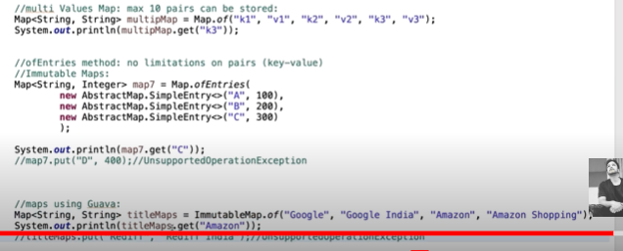

Synchronized Collections in HashMap:
1. HashTable
2. SynchronizedMap
3. ConcurrentHashMap
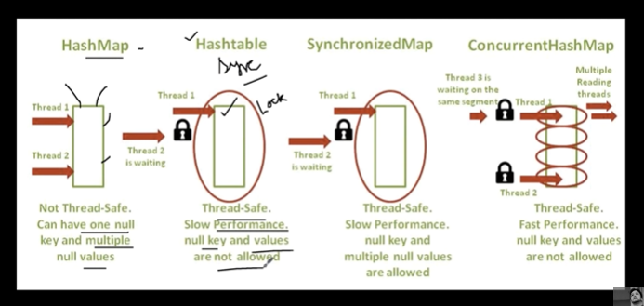
In concurrentHashMap Segment level lock will be applied so it has the fast performance and no thread need to wait outside until one thread completes it work.
Single thread can access the segment and can read the value unlike the hashtable.
ConcurrentHashMap is preferred on hash table.
SynchronizedMap creation code:
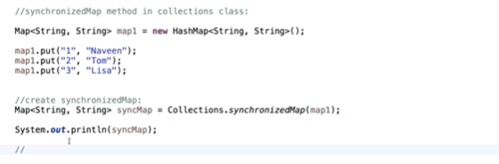

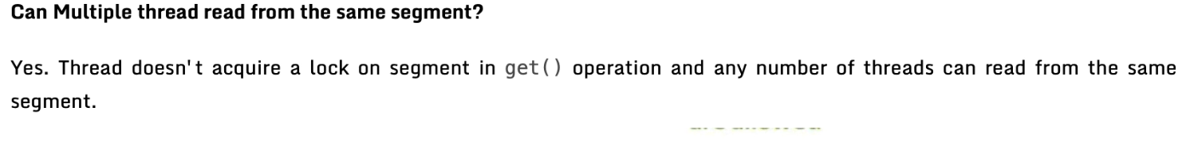
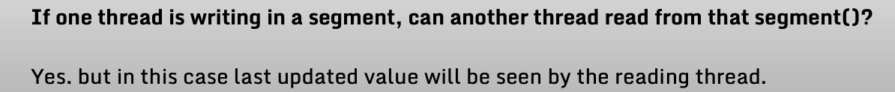
ConcurrentHashMap creation code:
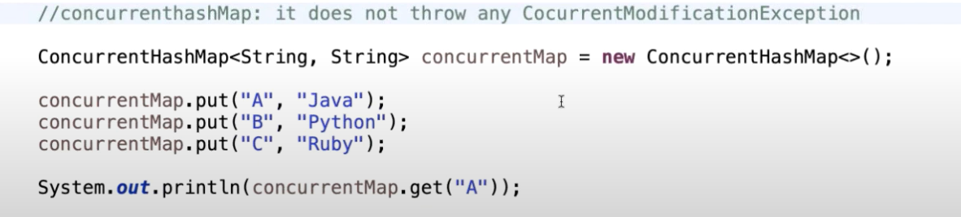
How to convert HashMap into a ArrayList?
import java.util.*;
class HelloWorld {
public static void main(String[] args) {
HashMap<String,Integer> map = new HashMap<>();
map.put("India",1000);
map.put("Us",2000);
map.put("UK",3000);
map.put("Ireland",1500);
map.put("France",900);
Iterator it = map.entrySet().iterator();
while(it.hasNext()){
System.out.println(it.next());
}
System.out.println("---------");
List<String> list = new ArrayList<>(map.keySet());
for(String s:list)
{
System.out.println(s);
}
System.out.println("---------");
List<Integer> list2 = new ArrayList<>(map.values());
for(Integer i : list2)
{
System.out.println(i);
}
}
}
LinkedHashMap:
1. It extends HashMap and implements Map interface.
2. It maintains the insertion order.
3. Stores the value in a node(Doubly linkes list).
4. Key-value pair
5. Not synchronized(not thread-safe).
6. contains one null key and multiple null values.
Internal working of LinkedHashMap:
In this we will have the (k,v) previous node and the after node.
How to implement LinkedHashMap.
Map<String,Integer> map = new LinkedHashMap<>();
To add the elements we will use put method.
map.put(key,value);
1. First it is divided into 16 segments.(Default capacity)
2. Concept of hashing remains the same.
3. Inside the put() method we will calculate the hashcode for the particular key. And do the modulo with that hashcode and the default capacity we will get the index and we will store that element in that particular index.

- If collision occurs we will point the elemet as the linkedlist node and in the linkedhashmap as we have seen the before node is pointing to the after node of the previous element and the current element afternode points to null.
- If the key is null then the hashcode of the key is 0 and it will get stored at the index 0.
- Questions of HashMap:
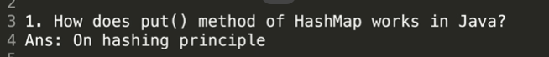
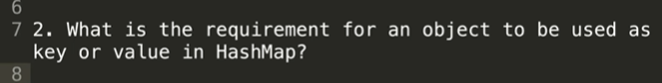
The key and value should implement hashcode and the equals method.
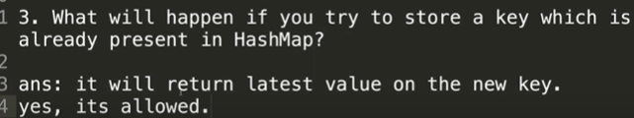
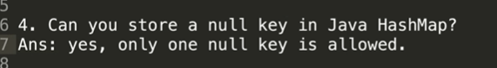
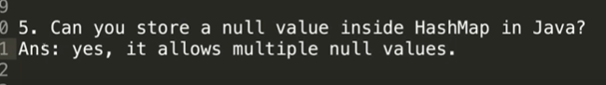
Internally uses hashtable.
Linkedlist and binary tree.

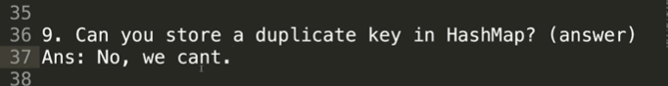
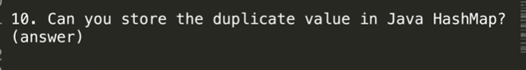
You cannot store the duplicate value but if you store the duplicate value you don’t get any error but it will return the latest value.
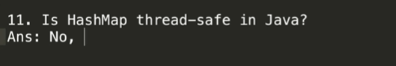
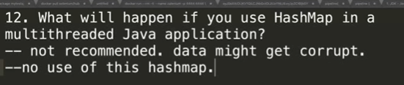

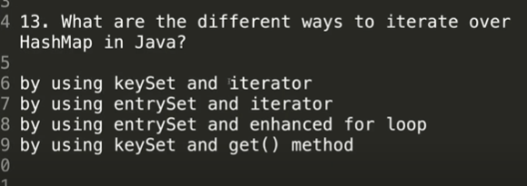
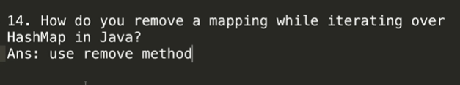
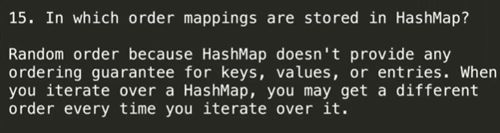
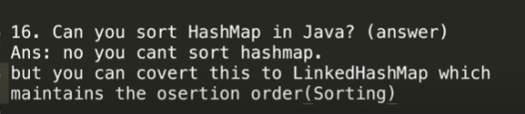
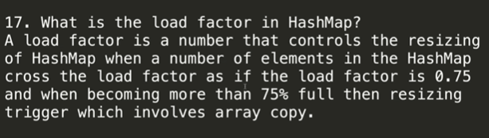
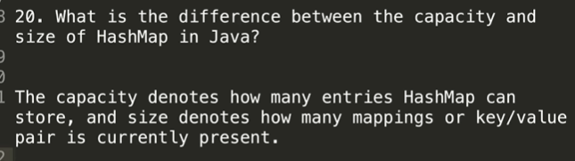

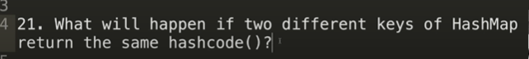
Collision will occur and the hashmap internally maintains the linkedlist and the element points to the next node after the threshold value(8) has been reached then it will act as a balanced tree.

TreeMap:
It is implementing a sorted map.
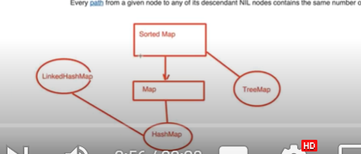
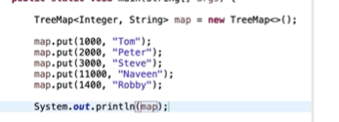
Maintains the order.
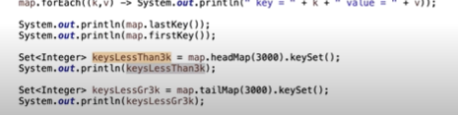
Internal mechanism of the treeMap:
Internally TreeMap maintains the Red Black tree.
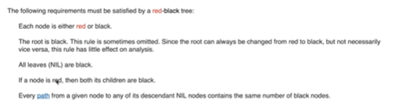
From root node to any node in the red-black tree each node should have the same no of black nodes.
In TreeMap elements are stored in the red-black tree based on the keys. Whether it is alphabetical or else It is numerical.

HashTable:
Implementation of HashMap.
Very old class in collection(legacy class)
Stores the values in the form of the key-value pair
It is synchronized so it does not allow any null keys or null values.
Initial capacity of hashtable is 11.
Load factor is 0.75
How the values get stored in the hashtable.
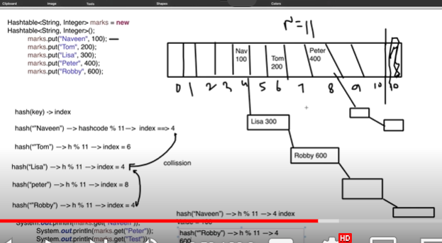
LinkedList:
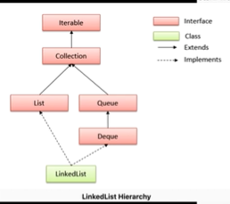

Types of linkedlist:
1. Singly linked list:
It takes the contiguous memory allocation.
When you are performing some operation for every manipulation shifiting is required this is one of the major disadvantage of arraylist.
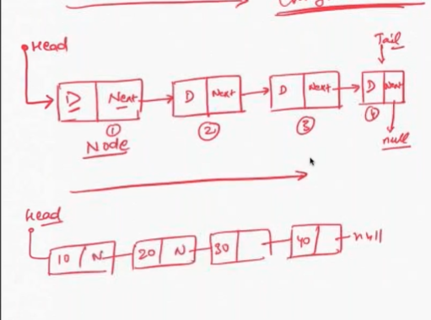
Creating linkedlist:
Public class MyLinkedList{
Class Node{
int data;
Node next;
Node(int data)
{
this.data=data;
next = null;
}
}
public void printMyLinkedList(){
Node n = head;
While(n!=null){
System.out.println(n.data);
n=n.next;
}
}

public static void main(String[] args)
{
MyLinkedlist ll = new LinkedList<>();
Node first = ll.new Node(10 );
ll.head=first;
Node second = ll.new Node(20);
first.next = second;
Node third = ll.new Node(30);
second.next = third;
ll.printMyLinkedList();
}
}

Default class in java
It can be used as stack, queue, list.
It allows the null entry.
Dynamic collection
Insertion and deletion can be easily implemented.
It contains duplicate elements.
It is not synchronized not thread safe.
In LL manipulation is fast as compared to arrays as we don’t need any shifiting.
LinkedlIst constructors:
Linkedlist()
LinkedList(Collection c)
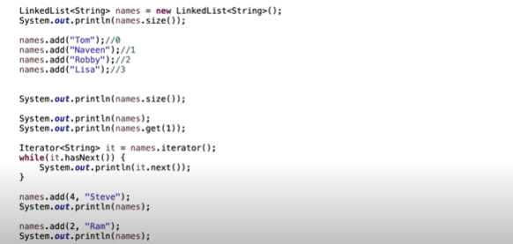

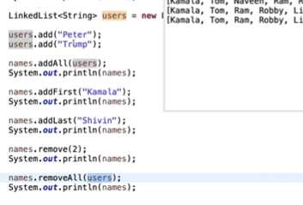

Vector:
It is a legacy collections
Implements the list interface
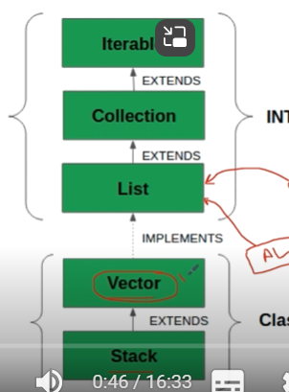
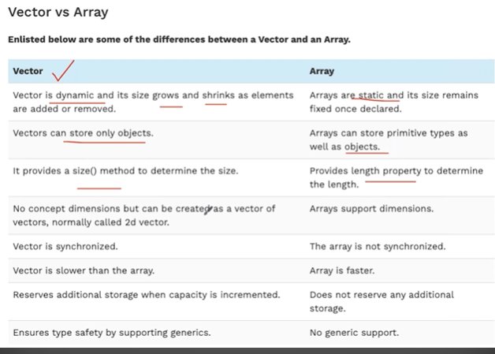

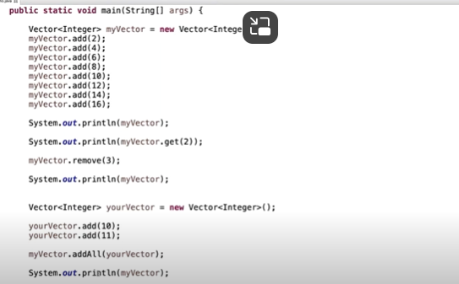
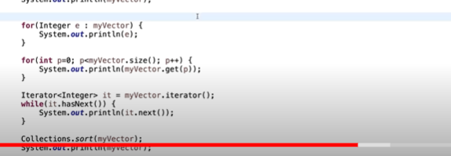
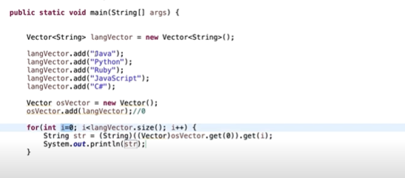

SET:

Only stores the unique values.
Not synchronized
Does not maintain any order

Different methods involved in set

Program to get the union of two sets.

To get the intersection of two sets

Get the difference between two sets.
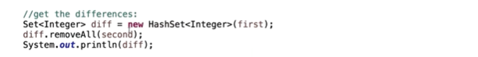

Enum Set:

It extends the abstract set.
It is not synchronized
High performance.
Faster than hashset.
All the methods of the enum set are implemented using bit wise operations.

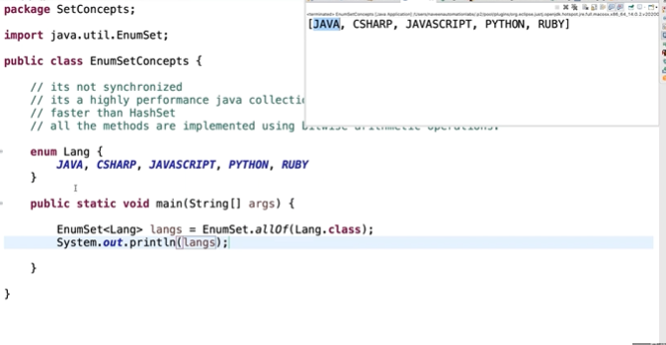
To get the blank enum set we can use the method we use noneOf() method.
Enum range set.
Of method:

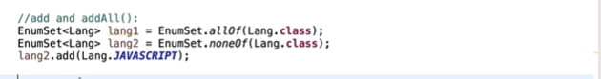

Ierating the elements.
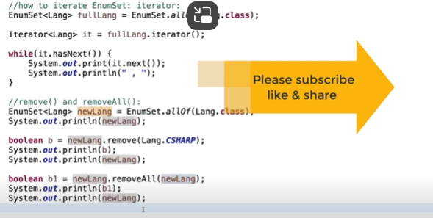

HashSet Internal working:
Internally hashset uses hashmap.
There are totally 4 constructors available in hashset.



Present is constant for all the keys.
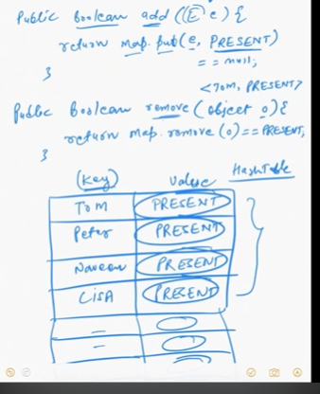

Constabt reference variable of the type object.

Values are always common for the every key.
For every key we have same constant address.
TreeSet
Definition: TreeSet is a class in Java that implements the NavigableSet interface, which is a part of the Java Collections Framework. It stores elements in a sorted, ascending order by default. Internally, TreeSet uses a TreeMap (which is a Red-Black tree, a self-balancing binary search tree).
Key Features:
- Sorted Order: The elements are automatically stored in a sorted order, either in natural order (i.e., elements are compared based on their Comparable implementation) or via a provided Comparator.
- No Duplicates: TreeSet does not allow duplicate elements.
- NavigableSet Interface: It provides methods like lower(), higher(), floor(), and ceiling() to navigate through the set.
- Performance: Operations like add, remove, and search have a time complexity of O(log n) because of the underlying tree structure.
Common Operations:
- add(E e): Adds the specified element to the set if it is not already present.
- remove(Object o): Removes the specified element from the set if it is present.
- first(): Retrieves the first (lowest) element.
- last(): Retrieves the last (highest) element.
- pollFirst(): Retrieves and removes the first (lowest) element.
- pollLast(): Retrieves and removes the last (highest) element.
Example Usage:
java
Copy code
TreeSet<Integer> treeSet = new TreeSet<>();
treeSet.add(10);
treeSet.add(5);
treeSet.add(20);
System.out.println(treeSet); // Output: [5, 10, 20]
Advantages:
- Automatically sorts elements.
- Provides efficient operations for navigation through the set.
Disadvantages:
- Slightly slower compared to HashSet or LinkedHashSet due to the overhead of maintaining the sorted order.
LinkedHashSet
Definition: LinkedHashSet is a class in Java that implements the Set interface and extends the HashSet class. It is similar to HashSet but with predictable iteration order. It uses a doubly-linked list to maintain the insertion order of elements.
Key Features:
- Preserves Insertion Order: Unlike HashSet, LinkedHashSet maintains the order in which the elements were inserted. This makes it predictable when iterating through the set.
- No Duplicates: Like all sets, it does not allow duplicate elements.
- HashTable and Linked List: Internally, it uses a combination of a HashTable and a doubly linked list.
- Performance: Operations like add, remove, and search have a time complexity of O(1), similar to HashSet, but with some additional overhead due to maintaining the linked list.
Common Operations:
- add(E e): Adds the specified element to the set if it is not already present.
- remove(Object o): Removes the specified element from the set if it is present.
- iterator(): Returns an iterator over the elements in the set in insertion order.
Example Usage:
java
Copy code
LinkedHashSet<String> linkedHashSet = new LinkedHashSet<>();
linkedHashSet.add("Apple");
linkedHashSet.add("Banana");
linkedHashSet.add("Orange");
System.out.println(linkedHashSet); // Output: [Apple, Banana, Orange]
Advantages:
- Maintains insertion order, making it useful for cases where the order of elements is important.
- Faster than TreeSet as it doesn't sort elements, but still provides O(1) performance for basic operations.
Disadvantages:
- Slightly slower than HashSet due to the overhead of maintaining the linked list.
When to Use:
- Use TreeSet when you need sorted elements and are okay with slightly slower performance.
- Use LinkedHashSet when you want to maintain the insertion order but don't need sorting, and you want faster access to elements.
Queue in Java
Definition: A Queue is an interface in Java, part of the Java Collections Framework, which represents a collection designed for holding elements prior to processing. It follows the FIFO (First In, First Out) principle, meaning the element added first will be the first to be removed.
Key Features:
- FIFO: The element that is added first is processed first, making it ideal for tasks like scheduling or managing resources.
- Interface: Queue is an interface, so it cannot be instantiated directly. Instead, we can use implementing classes like LinkedList, PriorityQueue, and ArrayDeque.
- Queue Operations: It provides methods to add, remove, and inspect elements in the queue.
Common Methods:
- offer(E e): Inserts the specified element into the queue (returns false if it fails).
- add(E e): Inserts the specified element into the queue (throws exception if it fails).
- poll(): Retrieves and removes the head of the queue, or returns null if the queue is empty.
- remove(): Retrieves and removes the head of the queue, throws an exception if the queue is empty.
- peek(): Retrieves the head of the queue without removing it, returns null if the queue is empty.
- element(): Retrieves the head of the queue without removing it, throws an exception if the queue is empty.
Example Usage:
java
Copy code
Queue<String> queue = new LinkedList<>();
queue.add("Apple");
queue.add("Banana");
queue.add("Orange");
System.out.println(queue.poll()); // Output: Apple
System.out.println(queue.peek()); // Output: Banana
Types of Queues in Java:
- PriorityQueue: Elements are ordered according to their natural order or by a Comparator provided at queue construction time. This means elements are not necessarily processed in FIFO order, but in priority order.
- LinkedList: It can act as a Queue because it implements both List and Deque interfaces. It maintains elements in FIFO order.
- ArrayDeque: A resizable array-based implementation of the Deque interface. More details about ArrayDeque are discussed below.
ArrayDeque in Java
Definition: ArrayDeque is a resizable array implementation of the Deque interface. It is a double-ended queue, meaning that it allows adding and removing elements from both the front and the back of the deque. It provides efficient and dynamic operations without capacity restrictions.
Key Features:
- Deque Interface: Implements the Deque interface, which allows it to function as both a stack (LIFO) and a queue (FIFO).
- Resizable Array: It automatically resizes itself when more capacity is needed.
- Efficient Operations: It provides efficient O(1) time complexity for adding and removing elements from both ends, unlike LinkedList, which may have O(n) complexity for some operations.
- No Capacity Restrictions: Unlike ArrayBlockingQueue, ArrayDeque does not have a fixed size and grows dynamically as elements are added.
- Null Elements: ArrayDeque does not permit null elements.
Common Methods:
- addFirst(E e): Inserts the specified element at the front of the deque.
- addLast(E e): Inserts the specified element at the end of the deque.
- offerFirst(E e): Inserts the specified element at the front of the deque (returns false if it fails).
- offerLast(E e): Inserts the specified element at the end of the deque (returns false if it fails).
- removeFirst(): Retrieves and removes the first element of the deque.
- removeLast(): Retrieves and removes the last element of the deque.
- pollFirst(): Retrieves and removes the first element, or returns null if the deque is empty.
- pollLast(): Retrieves and removes the last element, or returns null if the deque is empty.
- peekFirst(): Retrieves the first element of the deque without removing it.
- peekLast(): Retrieves the last element of the deque without removing it.
Example Usage:
java
Copy code
ArrayDeque<Integer> deque = new ArrayDeque<>();
deque.addLast(1); // Adding element to the end of the deque
deque.addFirst(2); // Adding element to the front of the deque
deque.addLast(3); // Adding element to the end of the deque
System.out.println(deque.pollFirst()); // Output: 2 (first element is removed)
System.out.println(deque.pollLast()); // Output: 3 (last element is removed)
Comparison of Queue and ArrayDeque
Feature | Queue | ArrayDeque
Type | Interface | Class
Nature | FIFO (First In, First Out) | Can act as both a queue (FIFO) and stack (LIFO)
Null Elements | Depends on implementation (e.g., PriorityQueue doesn't allow null) | Null elements are not allowed
Order | Depends on implementation (PriorityQueue is priority-based, LinkedList is FIFO) | FIFO for queue behavior, LIFO for stack behavior
Performance | Varies depending on implementation | O(1) for most operations at both ends
Resizable | Depends on implementation (e.g., PriorityQueue can resize dynamically) | Automatically resizes without capacity restrictions
Use Cases | Ideal for processing tasks in a specific order (e.g., job scheduling) | Efficient for both queue and stack operations, dynamic resizing
When to Use:
- Use Queue when you need basic FIFO functionality, especially for tasks like scheduling, task processing, and resource management.
- Use ArrayDeque when you need flexibility for both FIFO and LIFO operations, such as in applications where you need both stack and queue behavior. It's also preferred when performance is critical, as it is faster and more efficient than LinkedList for most operations.

Priority queue:
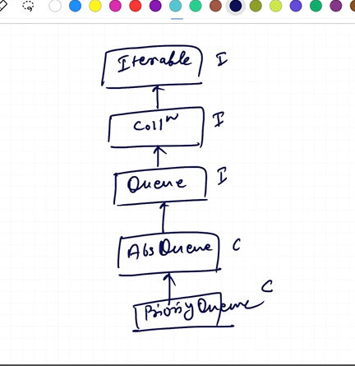
Adding the elements according to the priority.
First we will add the highest elements first .
Can use the custom comparator.

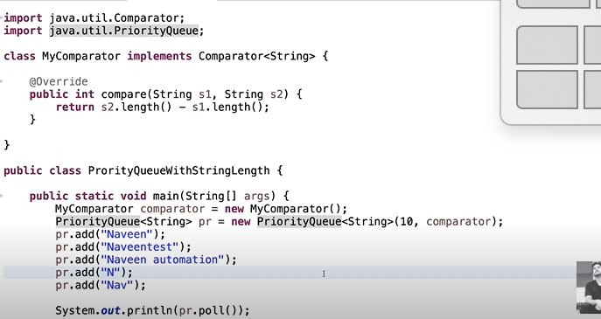

The Clonable and Serializable interfaces in Java are marker interfaces that signal to the JVM that a class supports certain behaviors: cloning and serialization, respectively.
1. Clonable Interface
- Purpose: This interface indicates that a class allows its objects to be cloned, which means creating a copy of the object.
- How It Works:
  - It doesn't have any methods. Instead, it serves as a marker to allow the Object.clone() method to perform a shallow copy of the object's fields.
  - To implement cloning, you need to override the clone() method from the Object class.
  - If a class implements Clonable, but its clone() method isn't properly overridden, the clone() method will throw a CloneNotSupportedException.
- Common Collections That Implement Clonable:
  - ArrayList
  - LinkedList
  - Vector
  - HashMap
  - Hashtable
  - HashSet
  - TreeSet
2. Serializable Interface
- Purpose: This interface indicates that a class's objects can be converted into a byte stream and subsequently deserialized back into a copy of the object. This is useful for saving objects to files, sending them over a network, or storing them in databases.
- How It Works:
  - Like Clonable, Serializable is a marker interface, so it has no methods.
  - To serialize an object, you use classes like ObjectOutputStream to write the object to a stream, and ObjectInputStream to read it back.
  - If an object references other objects, those must also implement Serializable, or the serialization will fail.
- Common Collections That Implement Serializable:
  - ArrayList
  - LinkedList
  - Vector
  - HashMap
  - Hashtable
  - HashSet
  - TreeSet
  - PriorityQueue
  - ConcurrentHashMap
Summary
- Clonable allows objects to be copied, and common collections like ArrayList, HashMap, and HashSet implement it.
- Serializable enables objects to be saved and restored, and many of the same collections also implement this interface, such as ArrayList, HashMap, and TreeSet.

Summary of Differences:
Aspect | Collection Interface | Collections Class
Type | Interface | Utility Class
Purpose | Represents a group of objects | Provides utility methods for operating on collections
Usage | Defines methods like add(), remove(), etc. | Offers static methods like sort(), reverse(), etc.
Inheritance | Root interface for List, Set, Queue | No inheritance; only contains static methods
In essence, Collection is a fundamental building block for holding groups of objects, while Collections provides convenient tools to manipulate and work with those groups of objects.

